Liftshare at Royal Devon University Healthcare NHS Foundation Trust
Liftshare offers another way of reducing your fuel costs, allows access to dedicated priority parking on site, reduces your own carbon footprint supporting the NHS commitment to Net Zero.

Dedicated Liftshare parking spaces at RD&E Wonford, RD&E Heavitree and North Devon District Hospital
RD&E Wonford:

To park on site, you will have to be signed up with Liftshare and have a valid Travel Pass. Colleagues who lift share will then be able to use the dedicated Liftshare parking spaces which are currently located at Car Park B. Please note, from 1 September the Liftshare parking spaces will be moving to car park D. Please ensure you trip authenticate your journey, as failure to do so may result in a parking charge notice (PCN).

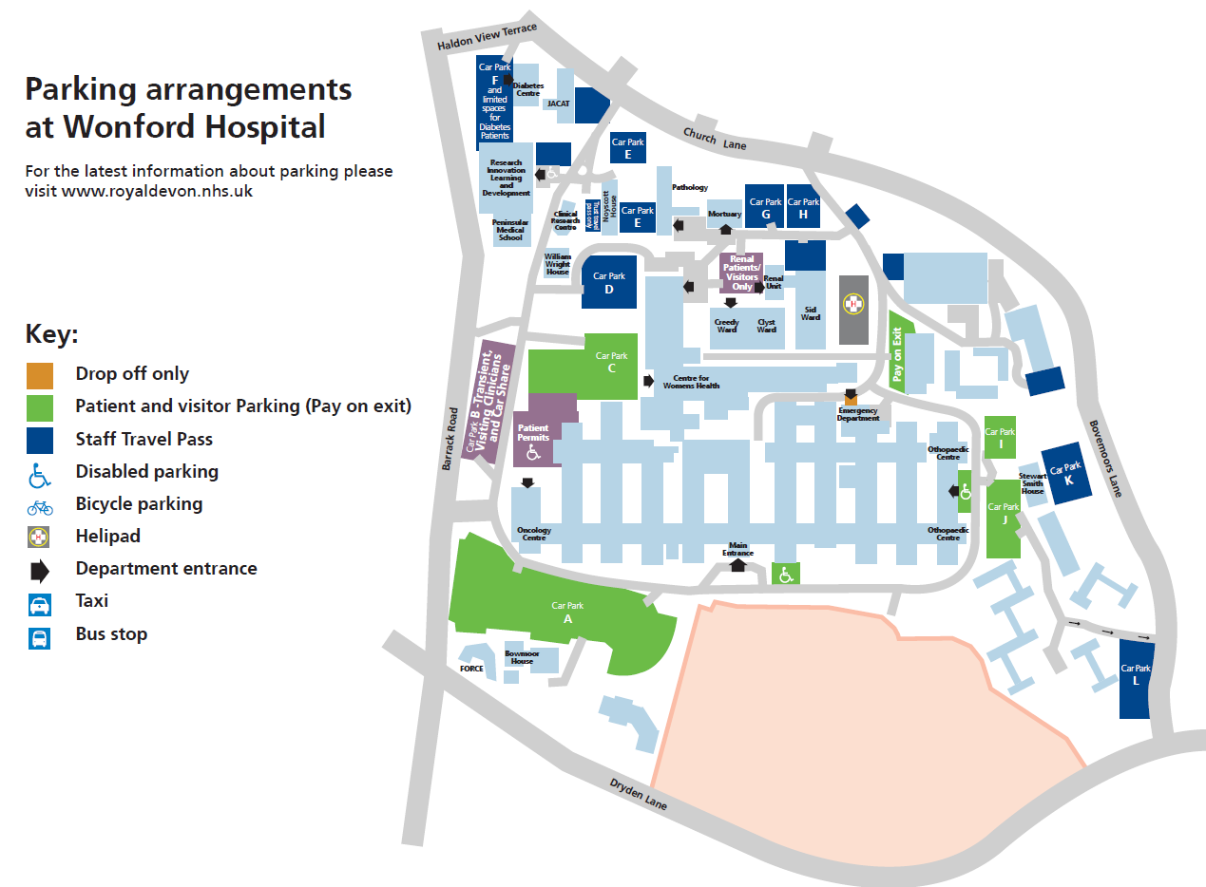
Location of current Liftshare parking

RD&E Heavitree:

To park on the Heavitree site, you will need to have signed up to Liftshare and have a valid Travel Pass. Colleagues who lift share will then be able to use the dedicated Liftshare parking spaces which are located at the area alongside the Physio department. Please ensure you trip authenticate your journey, as failure to do so may result in a parking charge notice (PCN).

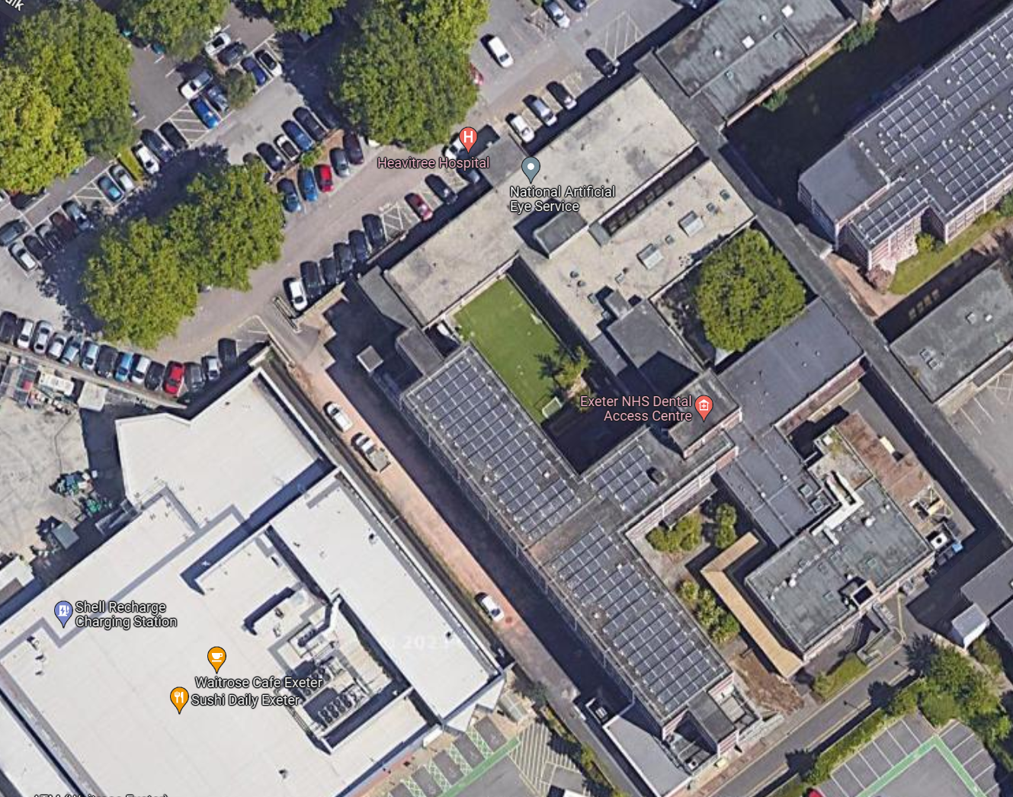
Location of current Liftshare parking

North Devon District Hospital (NDDH):

To park on the NDDH site, you will to be signed up with Liftshare and have a valid Car Parking Permit. Colleagues who lift share will then be able to use the dedicated Liftshare parking spaces which are located at the area adjacent to the Fern Centre. Please ensure you trip authenticate your journey, as failure to do so may result in a parking charge notice (PCN).

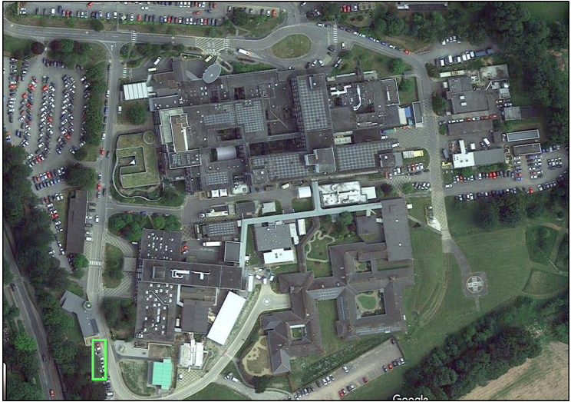
Location of current Liftshare parking

When parking in the dedicated Liftshare spaces at RD&E Wonford, RD&E Heavitree and NDDH, you are required to trip authenticate using the Liftshare app. Failure to trip authenticate may result in a Parking Charge Notice. Further details about how to trip authenticate below.

Community sites:

There are no dedicated Liftshare spaces at our community sites, so please continue to park as normal.

How to join Royal Devon Liftshare community:

Via a browser (i.e. Google) | Via the free Liftshare App
- Go to rde.liftshare.com (no www. required)  - Join using your Trust nhs.net email address  - Verify account via the activation email  - Sign back into your account  - Download the free ‘Liftshare App’ | - Download the free Liftshare App  - Select ‘Join Liftshare’  - Select ‘Join a community’  - Type and Find: ‘Royal Devon NHS’  - Join using your Trust nhs.net email address  - Verify your account via the activation email

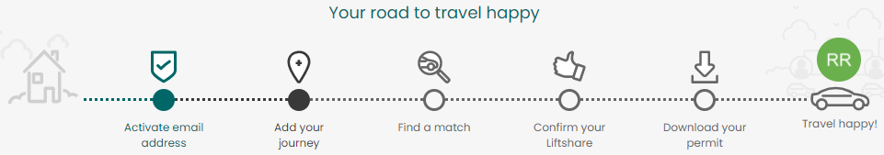

Liftshare Trip Authentication

Once you have created a Liftshare account, you can post your journey details and find a match to Liftshare with. Once you have found a suitable Liftshare partner you can ‘ask to share’. A Liftshare Team will be created once a request to share has been accepted.

- Once you arrive at the destination to pick up your Liftshare partner, you will all need to open the Liftshare app
- Click the ‘authenticate’ button
- Select if you are a driver or a passenger
- Scan the QR code on your Liftshare partner’s screen
Following this process will authenticate your journey and allow you to access dedicated Liftshare parking at RD&E Wonford, RD&E Heavitree and NDDH.

If you are parking at a community site, this process will log your journey and track the miles and carbon saved by lift sharing.

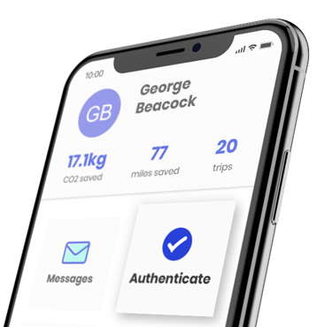
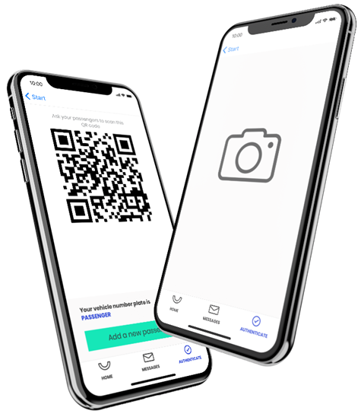

Royal Devon permit applications

Frequently Asked Questions

Why has the Trust signed up for this scheme?

The Trust has signed up to the scheme to help colleagues save money, save fuel, reduce their carbon footprint and assist with on-site parking. In line with our Green Plan, Liftshare also helps us to reduce our carbon footprint associated with travel.

How do I save money?

By sharing the journey, you save on the cost of fuel by only paying a share of the car parking fees and fuel for your journey. For example, if four people lift share, the parking charge can be divided across all four members of the Liftshare group.

What happens if I only share with one person and they are on holiday, or off sick?

If you are signed up to the scheme and cannot trip authenticate because your car share partner is on holiday or off sick, you will have to park in the normal staff car parks on-site and pay the relevant fee for doing so. Please ensure you have a valid permit that entitles you to park on-site.

